COURSE: MLA02 - Fundamentals of Machine Learning Name: EKALAIVAN L
DATE: 28.10.2026 Reg.no: 192524450

EXPERIMENT 1: Write a Python program to implement the FIND-S algorithm
Aim
To implement and demonstrate the FIND-S algorithm for finding the most specific hypothesis based on a given set of training data samples.
Algorithm
Step 1: Start the program.
Step 2: Read the training data from the CSV file.
Step 3: Initialize the hypothesis h to the most specific hypothesis <0, 0, 0, 0, 0, 0>.
Step 4: Take each training example in turn and check whether it is a positive example; ignore the negative examples.
Step 5: For a positive example, compare each attribute value with the corresponding value in h.
Step 6: If the value in h is 0, replace it with the attribute value of the example.
Step 7: If the value in h differs from the attribute value, replace it with "?".
Step 8: Repeat Steps 4-7 for all the training examples.
Step 9: Display the hypothesis after each example.
Step 10: Display the final most specific hypothesis.
Step 11: Stop the program.
Program:
Dataset (enjoysport.csv):
Sky,AirTemp,Humidity,Wind,Water,Forecast,EnjoySport
Sunny,Warm,Normal,Strong,Warm,Same,Yes
Sunny,Warm,High,Strong,Warm,Same,Yes
Rainy,Cold,High,Strong,Warm,Change,No
Sunny,Warm,High,Strong,Cool,Change,Yes

import pandas as pd

data = pd.read_csv('enjoysport.csv')
print("Training Data:\n", data, "\n")

attributes = data.iloc[:, :-1].values
target = data.iloc[:, -1].values

hypothesis = ['0'] * attributes.shape[1] # most specific hypothesis
for i, row in enumerate(attributes):
if target[i] == 'Yes': # consider positive examples only
for j, val in enumerate(row):
if hypothesis[j] == '0':
hypothesis[j] = val
elif hypothesis[j] != val:
hypothesis[j] = '?'
print(f"Hypothesis after example {i+1}: {hypothesis}")

print("\nMost specific hypothesis:", hypothesis)
Output
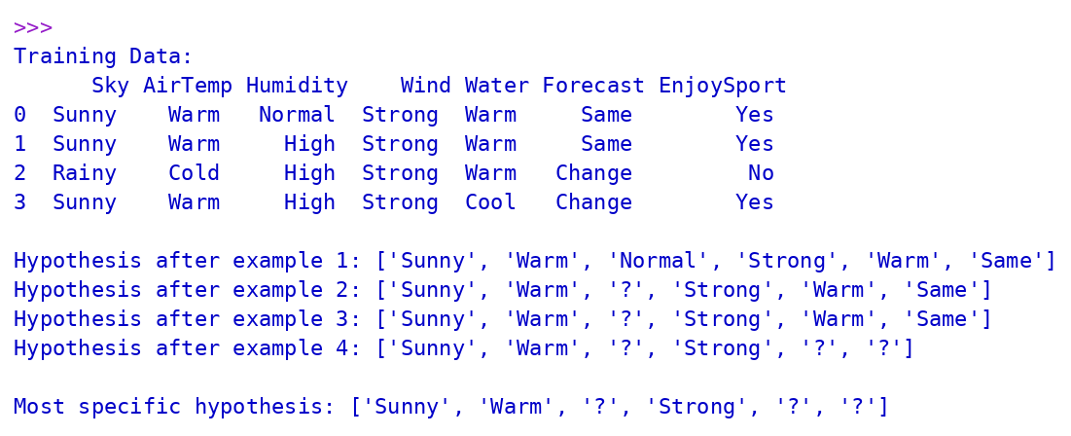
Result
The FIND-S algorithm was successfully implemented using Python, and the most specific hypothesis <Sunny, Warm, ?, Strong, ?, ?> was obtained for the given training data.
EXPERIMENT 2: Write a Python program to implement the Candidate-Elimination algorithm
Aim
To implement the Candidate-Elimination algorithm in Python for training examples stored in a .CSV file and to output the description of the set of all hypotheses consistent with the training examples.
Algorithm
Step 1: Start the program.
Step 2: Read the training examples from the CSV file.
Step 3: Initialize the specific boundary S with the first example and the general boundary G with the most general hypotheses.
Step 4: For each positive example, generalize S wherever its value differs from the example and update G.
Step 5: For each negative example, specialize G using the values of S wherever they differ from the example.
Step 6: Display S and G after each training example.
Step 7: Remove the fully general hypotheses from G after all the examples are processed.
Step 8: Repeat Steps 4-7 until all the training examples are used.
Step 9: Display the final specific and general boundaries, which describe the version space.
Step 10: Stop the program.
Program:
Dataset (enjoysport.csv):
Sky,AirTemp,Humidity,Wind,Water,Forecast,EnjoySport
Sunny,Warm,Normal,Strong,Warm,Same,Yes
Sunny,Warm,High,Strong,Warm,Same,Yes
Rainy,Cold,High,Strong,Warm,Change,No
Sunny,Warm,High,Strong,Cool,Change,Yes

import pandas as pd
import numpy as np

data = pd.read_csv('enjoysport.csv')
concepts = np.array(data.iloc[:, :-1])
target = np.array(data.iloc[:, -1])

def fmt(h):
return '<' + ', '.join(h) + '>'

def learn(concepts, target):
n = concepts.shape[1]
specific = concepts[0].copy()
general = [["?" for _ in range(n)] for _ in range(n)]
for i, h in enumerate(concepts):
if target[i] == "Yes":
for x in range(n):
if h[x] != specific[x]:
specific[x] = '?'
general[x][x] = '?'
if target[i] == "No":
for x in range(n):
if h[x] != specific[x]:
general[x][x] = specific[x]
else:
general[x][x] = '?'
shown = [g for g in general if g != ['?'] * n] or [['?'] * n]
print(f"\nStep {i+1}\nS: {fmt(specific)}\nG: {' '.join(fmt(g) for g in shown)}")
general = [g for g in general if g != ['?'] * n]
return specific, general

s_final, g_final = learn(concepts, target)
print("\nFinal Specific hypothesis S:", fmt(s_final))
print("Final General hypotheses G :", " ".join(fmt(g) for g in g_final))
Output
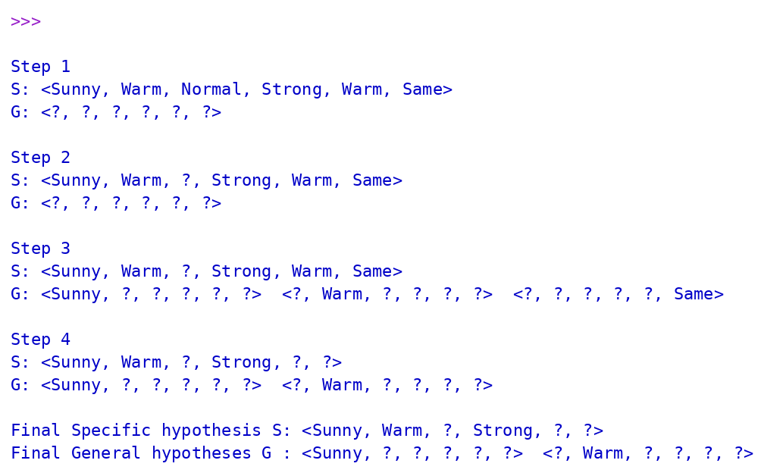
Result
The Candidate-Elimination algorithm was successfully implemented using Python. The version space is bounded by S = <Sunny, Warm, ?, Strong, ?, ?> and G = {<Sunny, ?, ?, ?, ?, ?>, <?, Warm, ?, ?, ?, ?>}.
EXPERIMENT 3: Write a Python program to implement the ID3 decision tree algorithm
Aim
To demonstrate the working of the decision tree based ID3 algorithm using an appropriate data set and to classify a new sample.
Algorithm
Step 1: Start the program.
Step 2: Create the PlayTennis training data set with the attributes Outlook, Temperature, Humidity and Wind.
Step 3: Calculate the entropy of the target attribute (PlayTennis).
Step 4: Calculate the information gain of every attribute.
Step 5: Select the attribute with the highest information gain as the decision node.
Step 6: Split the data set on the values of the selected attribute.
Step 7: Repeat Steps 4-6 recursively for each subset until all the examples in it belong to the same class.
Step 8: Display the decision tree.
Step 9: Classify a new sample by traversing the tree from the root to a leaf node.
Step 10: Display the predicted class.
Step 11: Stop the program.
Program:
import pandas as pd
import numpy as np
from pprint import pprint

data = pd.DataFrame({
'Outlook':['Sunny','Sunny','Overcast','Rain','Rain','Rain','Overcast','Sunny','Sunny','Rain','Sunny','Overcast','Overcast','Rain'],
'Temperature':['Hot','Hot','Hot','Mild','Cool','Cool','Cool','Mild','Cool','Mild','Mild','Mild','Hot','Mild'],
'Humidity':['High','High','High','High','Normal','Normal','Normal','High','Normal','Normal','Normal','High','Normal','High'],
'Wind':['Weak','Strong','Weak','Weak','Weak','Strong','Strong','Weak','Weak','Weak','Strong','Strong','Weak','Strong'],
'PlayTennis':['No','No','Yes','Yes','Yes','No','Yes','No','Yes','Yes','Yes','Yes','Yes','No']})

def entropy(col):
p = col.value_counts(normalize=True)
return -sum(p * np.log2(p))

def info_gain(df, attr, target='PlayTennis'):
total = entropy(df[target])
weighted = sum((len(sub)/len(df)) * entropy(sub[target]) for _, sub in df.groupby(attr))
return total - weighted

def id3(df, features, target='PlayTennis'):
if df[target].nunique() == 1:
return df[target].iloc[0]
if not features:
return df[target].mode()[0]
gains = {f: info_gain(df, f) for f in features}
best = max(gains, key=gains.get)
tree = {best: {}}
for val, sub in df.groupby(best):
tree[best][val] = id3(sub, [f for f in features if f != best])
return tree

def classify(tree, sample):
if not isinstance(tree, dict):
return tree
attr = next(iter(tree))
return classify(tree[attr][sample[attr]], sample)

print("Entropy of dataset: %.4f" % entropy(data['PlayTennis']))
feats = list(data.columns[:-1])
for f in feats:
print(f"Information Gain({f}) = {info_gain(data, f):.4f}")
tree = id3(data, feats)
print("\nDecision Tree:")
pprint(tree)
new = {'Outlook':'Sunny','Temperature':'Cool','Humidity':'High','Wind':'Strong'}
print("\nNew sample:", new)
print("Predicted class (PlayTennis):", classify(tree, new))
Output
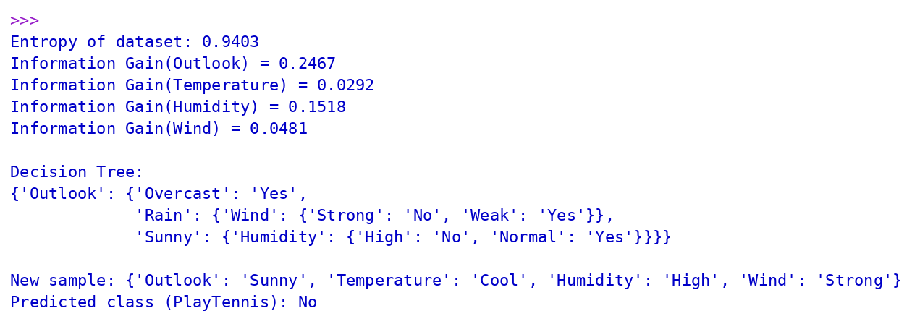
Result
The ID3 decision tree was successfully built using Python with Outlook as the root node, and the new sample <Sunny, Cool, High, Strong> was classified as PlayTennis = No.
EXPERIMENT 4: Write a Python program to build an Artificial Neural Network using the Backpropagation algorithm
Aim
To build an Artificial Neural Network by implementing the Backpropagation algorithm and to test it using an appropriate data set.
Algorithm
Step 1: Start the program.
Step 2: Define the training data (XOR problem) and the sigmoid activation function with its derivative.
Step 3: Initialize the weights and biases of the network with small random values.
Step 4: Perform the forward pass: calculate the hidden layer activations and the output of the network.
Step 5: Calculate the error between the target output and the actual output.
Step 6: Perform the backward pass: calculate the delta of the output layer and propagate it back to the hidden layer.
Step 7: Update the weights and biases using the learning rate.
Step 8: Repeat Steps 4-7 for the required number of epochs and display the error periodically.
Step 9: Test the trained network on all the input patterns.
Step 10: Display the predicted outputs.
Step 11: Stop the program.
Program:
import numpy as np
np.random.seed(1)

# Training data: XOR problem
X = np.array([[0,0],[0,1],[1,0],[1,1]])
y = np.array([[0],[1],[1],[0]])

def sigmoid(x): return 1 / (1 + np.exp(-x))
def dsigmoid(a): return a * (1 - a)

inputs, hidden, outputs = 2, 4, 1
W1 = np.random.uniform(-1, 1, (inputs, hidden)); b1 = np.zeros((1, hidden))
W2 = np.random.uniform(-1, 1, (hidden, outputs)); b2 = np.zeros((1, outputs))
lr, epochs = 0.5, 10000

for ep in range(epochs):
# Forward pass
h = sigmoid(X @ W1 + b1)
out = sigmoid(h @ W2 + b2)
# Backward pass
error = y - out
d_out = error * dsigmoid(out)
d_hid = (d_out @ W2.T) * dsigmoid(h)
# Weight update
W2 += lr * h.T @ d_out; b2 += lr * d_out.sum(axis=0, keepdims=True)
W1 += lr * X.T @ d_hid; b1 += lr * d_hid.sum(axis=0, keepdims=True)
if ep % 2000 == 0:
print(f"Epoch {ep:5d} Loss (MSE): {np.mean(error**2):.6f}")

print(f"Epoch {epochs:5d} Loss (MSE): {np.mean((y-out)**2):.6f}")
print("\nInput Target Predicted Class")
for xi, ti, oi in zip(X, y, out):
print(f"{xi} {ti[0]} {oi[0]:.4f} {int(oi[0] > 0.5)}")
Output
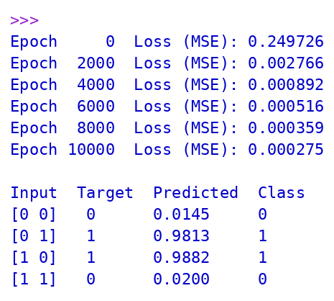
Result
The Artificial Neural Network was successfully built using the Backpropagation algorithm, and the trained network classified all the XOR input patterns correctly.
EXPERIMENT 5: Write a Python program to implement the K-Nearest Neighbours (K-NN) algorithm
Aim
To write a Python program to implement the K-Nearest Neighbours (K-NN) algorithm.
Algorithm
Step 1: Start the program.
Step 2: Load the Iris data set and split it into training and testing sets.
Step 3: Choose the value of K (number of neighbours).
Step 4: For each test sample, calculate the Euclidean distance to all the training samples.
Step 5: Select the K training samples with the smallest distances.
Step 6: Assign the class that occurs most often among the K neighbours.
Step 7: Repeat Steps 4-6 for all the test samples.
Step 8: Calculate the accuracy and display the confusion matrix.
Step 9: Classify a new sample and compare the accuracy for different values of K.
Step 10: Stop the program.
Program:
import numpy as np
from sklearn.datasets import load_iris
from sklearn.model_selection import train_test_split
from sklearn.neighbors import KNeighborsClassifier
from sklearn.metrics import accuracy_score, confusion_matrix

iris = load_iris()
X_train, X_test, y_train, y_test = train_test_split(
iris.data, iris.target, test_size=0.3, random_state=42)

knn = KNeighborsClassifier(n_neighbors=5)
knn.fit(X_train, y_train)
y_pred = knn.predict(X_test)

print("Accuracy:", round(accuracy_score(y_test, y_pred), 4))
print("Confusion Matrix:\n", confusion_matrix(y_test, y_pred))

sample = [[5.1, 3.5, 1.4, 0.2]]
print("\nNew sample:", sample[0])
print("Predicted class:", iris.target_names[knn.predict(sample)[0]])

print("\nAccuracy for different K values:")
for k in [1, 3, 5, 7, 9]:
m = KNeighborsClassifier(n_neighbors=k).fit(X_train, y_train)
print(f"K = {k}: {accuracy_score(y_test, m.predict(X_test)):.4f}")
Output
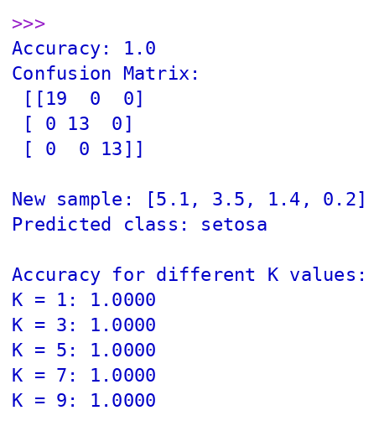
Result
The K-Nearest Neighbours algorithm was successfully implemented using Python, and the Iris data set was classified with an accuracy of 100%.

